Systemic Problem Analysis
  - IIIT Hyderabad Breakfast Mess System
Table of Contents

Overview
Students register for breakfast at IIIT Hyderabad in large numbers, but a large share never show up to eat it. This document looks at why, using the Iceberg Model taught in this course: an event is one thing that actually happened, a pattern is what keeps happening across many events, a structure is the rule or design that produces the pattern, and a mental model is the belief that keeps that structure standing. Read from the bottom up: a belief shapes a rule, the rule produces a habit, the habit shows up as a specific incident you can point to.
Claims below are marked confirmed, single sourced, candidate, or assumed. Confirmed means a named source stated it directly or it was independently backed up. Single sourced means one account only. Candidate means it’s a reasonable read of the facts but not yet checked. Assumed means it’s a systems thinking judgment, offered honestly, not proof.
The biggest finding in this whole analysis is simple: the institution has already run a version of breakfast where billing tracks who actually shows up, and it worked. During a gas shortage and during holidays when students leave campus, registration stopped being compulsory. Students could just walk in and scan a QR code, or register a day or two ahead at any mess instead of being locked into one four days out. If you didn’t register and didn’t show up, you weren’t charged. That whole model already exists inside this institution’s own recent history. It gets switched back off once the shortage or the holiday ends, and nobody appears to have gone back and asked whether any part of it should stay.

1. The Iceberg Model, Chain by Chain
Six areas of this system were traced from event up to belief. Each one gets its own events, patterns, structures, and mental models, listed out rather than folded into one paragraph, because the point of doing this properly is seeing how many different beliefs and rules are actually stacked underneath one visible symptom.

Chain 1: Students register and don’t show up
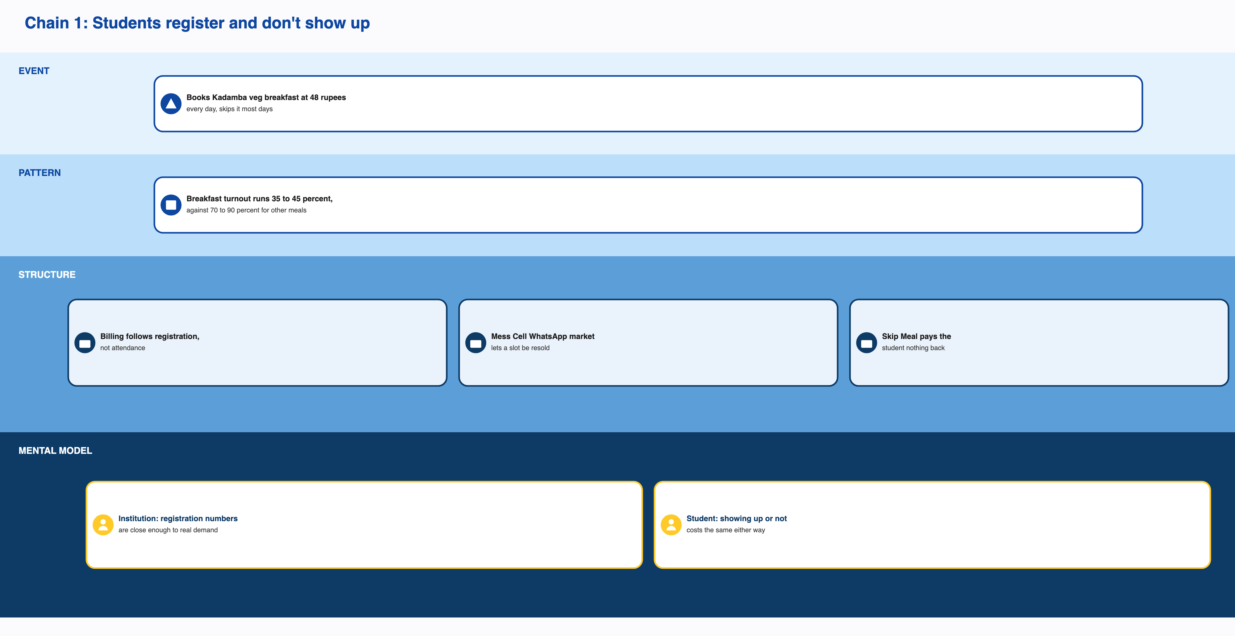
Chain 1: Students register and don’t show up
Events
- A student who was interviewed said they book Kadamba veg breakfast for forty eight rupees every day and skip it most days.
- The same student cancels roughly five times a month and has never once used Skip Meal, because in their own words it doesn’t give any money back.
- Another student registers for the entire month at Kadamba specifically, because in their words it’s hard to get and fills up, and resells on the Mess Cell WhatsApp group only rarely, when a slot happens to go for a good price.
- A third student buys and sells registrations on Mess Cell for lunch and dinner but says they’ve never done it for breakfast.
- On one date the mess tracked, Kadamba served between fifty one and seventy nine percent of the people registered there. Bakul, on the same day, served between eleven and thirty one percent.
Patterns
- Registration beats attendance every month, and it’s worse for breakfast than for any other meal. Breakfast turnout runs somewhere between thirty five and forty five percent, against seventy percent for general items and over ninety for the most popular ones.
- Nobody interviewed has ever gotten anything out of Skip Meal.
- Four of the six students interviewed use Mess Cell regularly.
- Everyone registers for the whole month rather than day to day.
Structures
- Billing is calculated off how many people registered, not who ate.
- Cancelling requires four days’ notice and tops out at five a month.
- Walking in without registering costs seventy to ninety percent more than the registered price.
- Mess Cell, an informal WhatsApp group, lets someone sell a slot they know they won’t use.
- Skip Meal tells the kitchen someone won’t show but pays that student nothing.
- Orders to the vendor lock in four days ahead of time.
- Skip Meal data only changes how much gets cooked that week. It never touches what’s already been ordered.
- A student who never registers at all is automatically put down for a vegetarian meal somewhere by default.
Mental models
- The mess office treats total registration numbers as a good enough stand in for real demand, and keeps billing that way even though it already knows the real gap and has already run a working alternative. This is the strongest and most confirmed belief in the whole analysis, because it survives contact with evidence that contradicts it.
- Students believe that once they’ve registered, showing up or not costs them the same either way.
- For at least one student, reselling gets you something back and Skip Meal doesn’t, so there’s no reason to bother with Skip Meal.
- For another, a slot at a popular mess needs to be grabbed early because it will disappear otherwise.
- It’s reasonable to assume the vendor has little reason to worry about actual turnout, since it gets paid on registrations either way.
Root cause. Billing tracks registration, not attendance. This one rule explains almost everything else in this chain, and the counterfactual has actually happened: when billing switched to tracking attendance, the gap it explains closed.

Chain 2: Food runs out before the mess closes
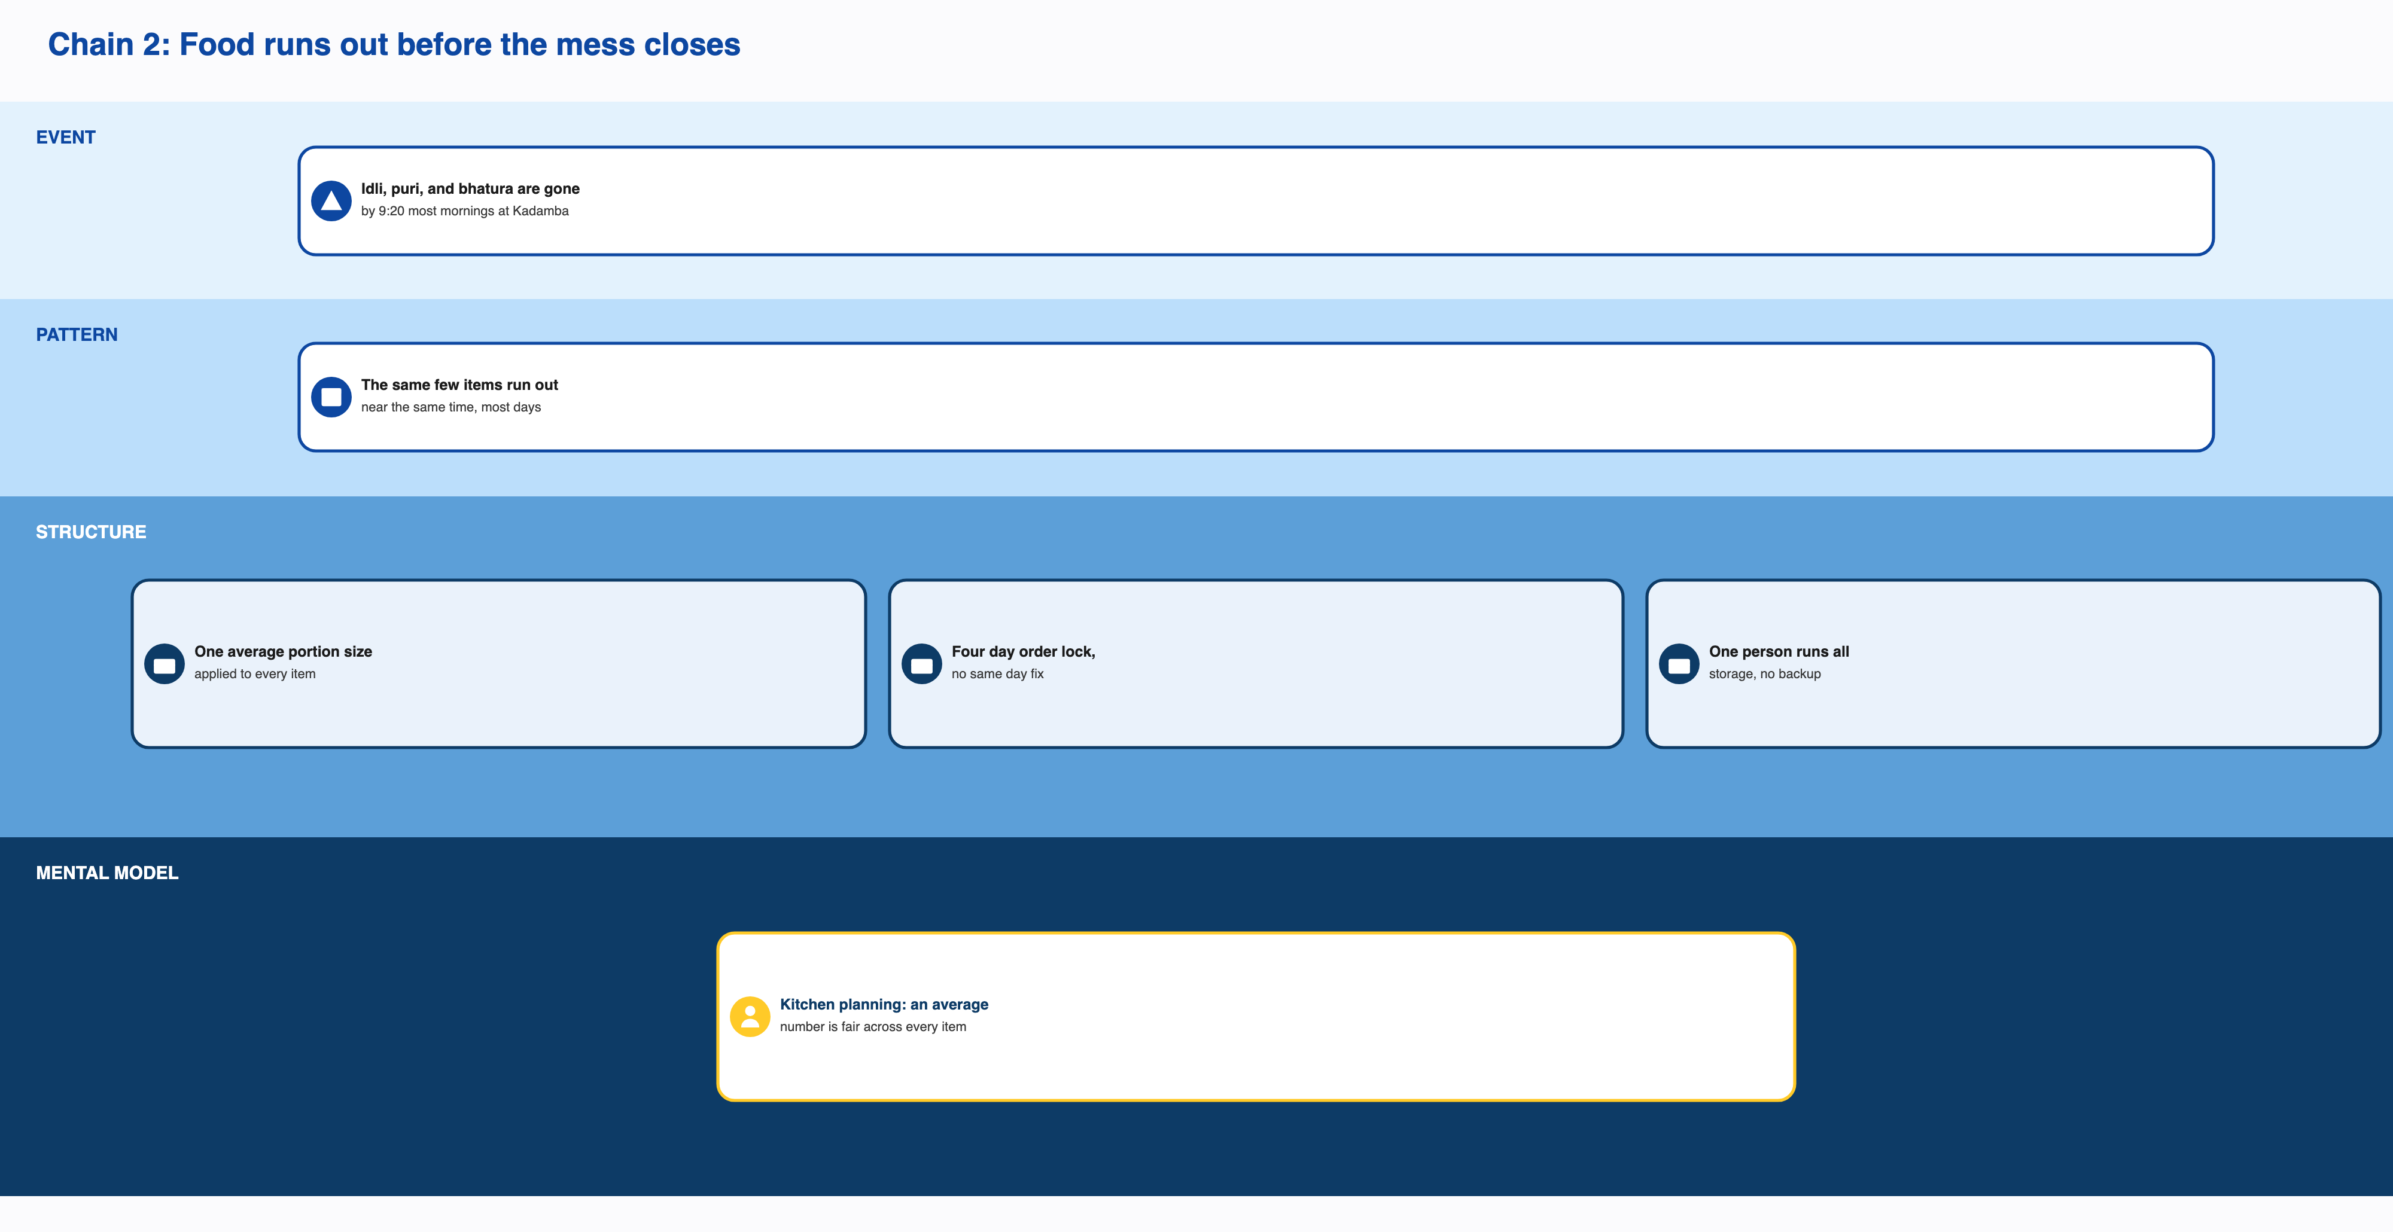
Chain 2: Food runs out before the mess closes
Events
- One student said that most mornings around 9:20, idli, puri, and bhatura are already gone at Kadamba, fruit isn’t restocked, and staff say more is coming before the 9:30 close but it usually doesn’t arrive.
- Another student described supply getting very low between 9:00 and 9:30, and said the mess can’t restock quickly enough on those mornings.
- The same sampled date mentioned above shows a real gap between what’s registered and what’s actually served, and it’s a different sized gap at each mess.
- A student described Kadamba as very crowded after roughly 9:15, to the point where getting everything you wanted wasn’t guaranteed.
Patterns
- The same handful of items run out near the same time most days.
- Crowding builds steadily toward the 9:20 to 9:30 window rather than hitting two separate peaks.
- The size of the attendance gap is very different mess to mess, even on the same day.
Structures
- Portions are set using one average consumption number applied the same way to every item, popular or not.
- One person manages both cold storage and dry storage, with nobody named as backup.
- A weekly stock check tracks broader trends but has no way to catch a same day swing.
- The four day order lock means nothing about that morning’s actual turnout can change what was bought.
- The whole window is two hours, 7:30 to 9:30, with a hard stop on new entries at 9:30.
Mental models
- It’s a reasonable guess that whoever plans portions treats an average number as fair to apply across every item, even ones that are clearly more popular than others.
- The same belief that procurement certainty matters more than matching food to real demand, which also drives the T-4 lock in chain one, shows up here too.
- Promising a restock seems to count as good enough on its own, even when it doesn’t usually happen.
Root cause. This traces back to the same billing and ordering structure as chain one, layered on top of an ordering method that has no way to see or react to a same day spike.

Chain 3: Complaints get ignored until something forces a response
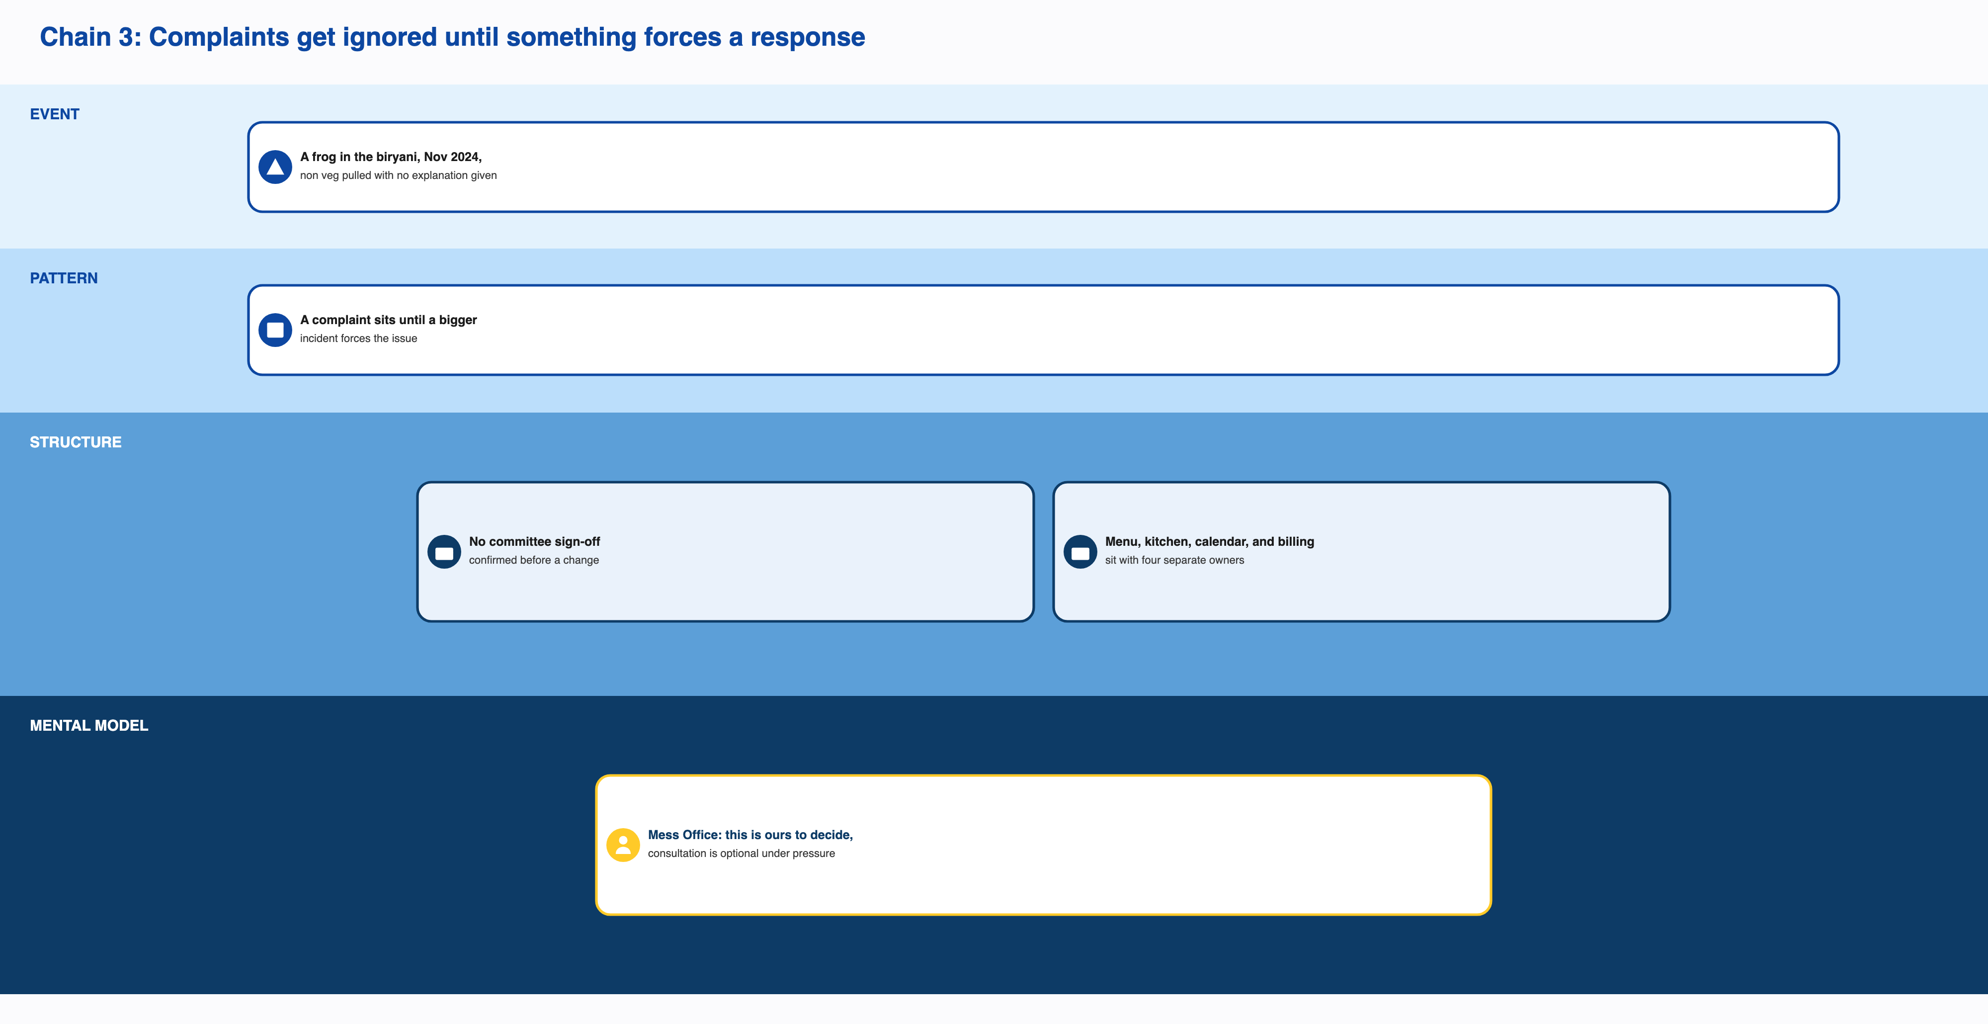
Chain 3: Complaints get ignored until something forces a response
Events
- In November 2024, a frog turned up in Kadamba’s chicken biryani. Non vegetarian meals at Kadamba were pulled without an official explanation of why.
- In December 2024, the cancellation cap was tightened. This came after a renovation at Kadamba added to the Mess Office’s workload. There’s no record of the committee signing off first. A student survey run by Ping showed most respondents unhappy about it, and Student Parliament representatives met with the Mess Office twice before the change went ahead anyway.
- Back in 2023, complaints about drinking water quality went unanswered for months, even after Parliament asked for testing, until more than thirty eight confirmed cases of typhoid forced the institution to respond.
Patterns
- A complaint sits without action until a bigger incident makes it impossible to ignore.
- When the Mess Office wants a change made quickly, it tends to act on its own rather than go through a consultation process.
Structures
- There’s no confirmed rule requiring committee approval before an operational change goes into effect.
- Menu decisions, kitchen execution, the academic calendar, and billing policy each sit with a different owner, and none of them overlaps with any other.
- Three feedback channels exist (an in app rating, email, and Ping’s reporting), and none of them has a confirmed case of producing a policy change on its own.
Mental models
- It’s reasonable to infer the Mess Office sees these decisions as theirs alone to make, with consultation as optional, especially when they’re under time pressure.
- The Mess Office’s own stated reason for the December tightening was reducing its own workload, regardless of what that cost students in flexibility.
Root cause. Nobody owns the whole picture (menu, kitchen, academic calendar, and billing sit apart from each other), and the system only reacts once something is loud enough to force it to.

Chain 4: A working fix already exists and gets switched off anyway
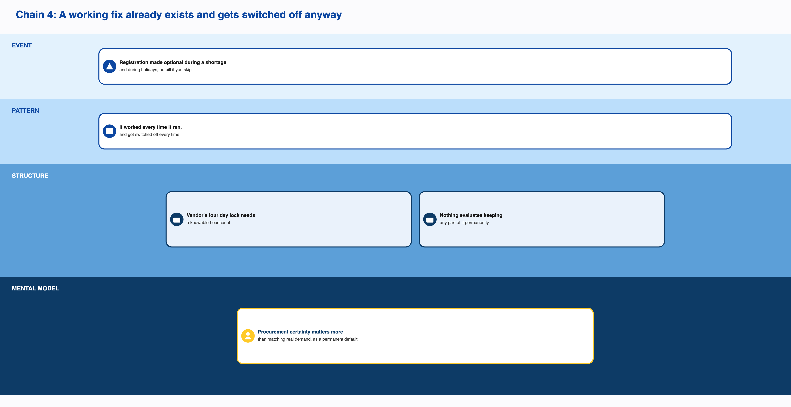
Chain 4: A working fix already exists and gets switched off anyway
Events
- During a gas shortage, the mess cut down to serving one item at the same price, and the cancellation cap was doubled from five to ten a month.
- During holidays and long weekends, Felicity being the named example, when a large share of students leave campus, registration stopped being required. Students could walk in and scan a QR code when they arrived, or register just one to two days ahead at any of the four messes instead of being tied to one specific mess four days out. Anyone who didn’t register and didn’t show up simply wasn’t billed.
Patterns
- Every time this ran, it worked. And every time, it got switched back off once the shortage or the holiday ended.
- There’s no sign it was ever evaluated afterward for keeping any part of it as a permanent option.
Structures
- The vendor’s four day lock only works if the total headcount is knowable that far in advance. A walk in model breaks that.
- Nothing in the system currently exists to evaluate whether a temporary fix should become a standing one.
- The cancellation cap is a number the institution has already shown it’s willing to move.
Mental models
- Procurement certainty seems to matter more to the institution than matching food to real demand, as a permanent default rather than something weighed case by case.
- Attendance based billing appears to be treated as acceptable only as an emergency measure, not as a real option on ordinary days.
Root cause. This is a live counterexample to chain one’s root cause. The gap between registration and attendance is not something the institution has failed to solve. It’s something the institution already solved once, twice actually, and chose not to keep. The most likely reason is that a permanent walk in model would take away the vendor’s four day lead time guarantee. That reasoning hasn’t been checked against the vendor’s actual contract terms anywhere in the evidence, so it stays a strong guess rather than a fact.

Chain 5: A real fix, and a shadow it cast
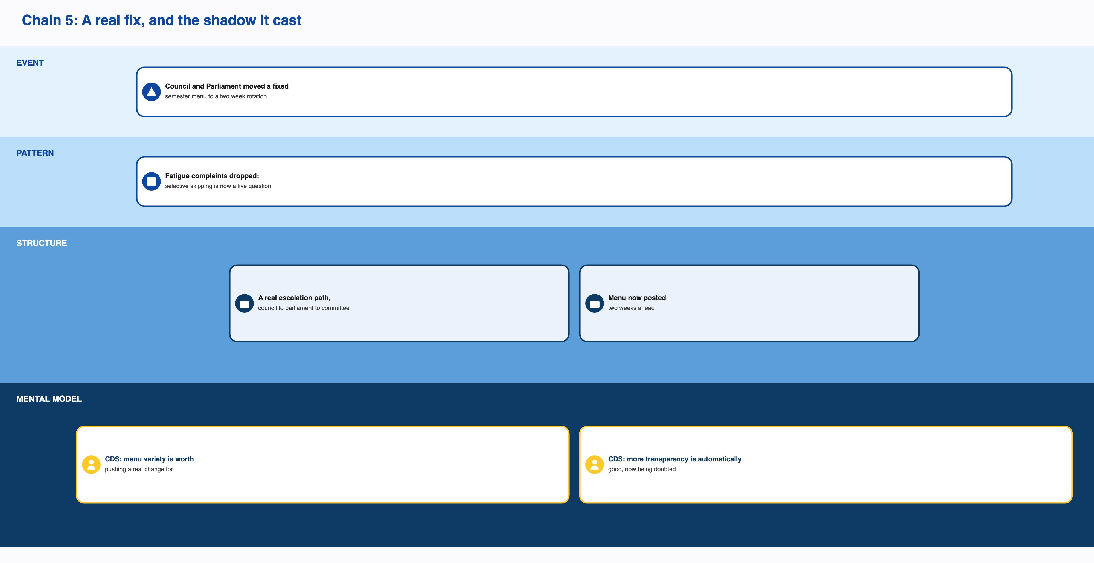
Chain 5: A real fix, and the shadow it cast
Events
- CDS convinced the Student Council, and the Student Council convinced Student Parliament, to move off a single semester long menu and onto one that rotates every two weeks.
- The CFS Chair raised, without being asked, a concern that once the menu is known in advance, students can decide ahead of time not to show up on days they don’t like what’s coming.
Patterns
- Complaints about menu fatigue dropped once the rotation started, according to the CFS Chair.
- Whether people are actually skipping known bad menu days hasn’t been checked against any student side data yet.
Structures
- A real path exists from student complaint to policy change: Student Council, then Parliament, then the Committee approving it. This time it actually worked.
- Feedback gets sorted by how loud it is. Low intensity goes straight to the CFS Head, high intensity escalates.
- The menu is now posted two weeks at a time and also changes monthly and seasonally.
Mental models
- CDS believes menu variety is worth pushing a real policy change for, and this time acted on that belief.
- CDS also believed, until recently, that more transparency about the menu is automatically a good thing. That belief is now being questioned by the same office that held it.
Root cause. This chain shows the opposite of chain three: proof that the system can respond when a problem is loud enough. The new risk it created (people skipping on menu days they already know they’ll dislike) comes from the same structure that made the fix possible in the first place. Visibility that helps with fatigue also helps with avoidance.

Chain 6: A meaningful slice of this isn’t a problem at all
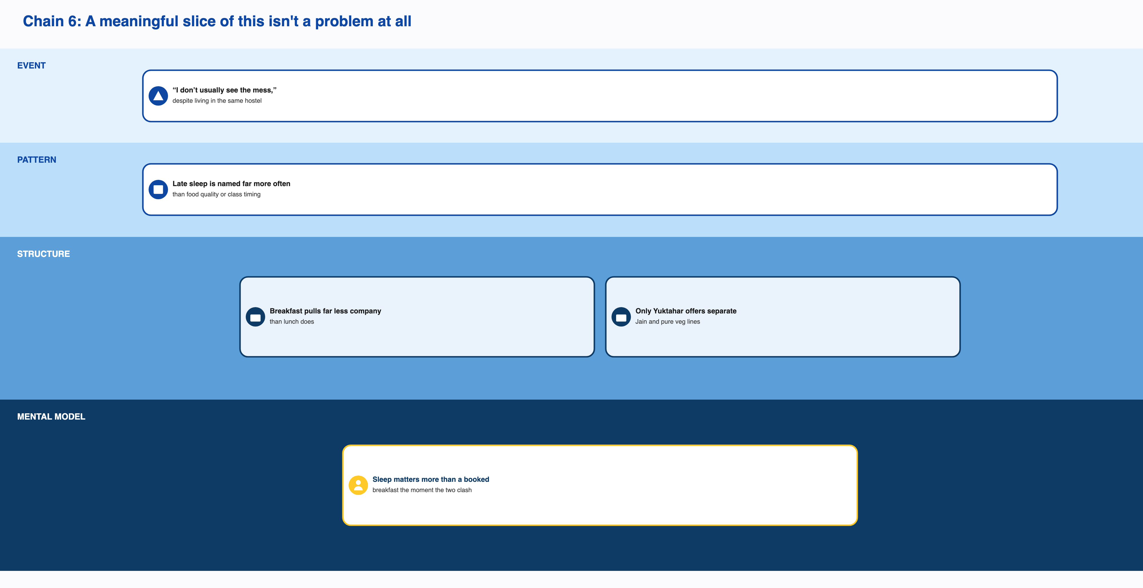
Chain 6: A meaningful slice of this isn’t a problem at all
Events
- One student said they practice intermittent fasting on purpose, stopped cooking breakfast for themselves years ago, and doesn’t usually even see the mess, despite living in the same hostel.
- Another said a friend’s absence wouldn’t really change whether they go.
- A third said friends are a reason to go, but not the deciding one. If everyone else skipped, they’d still go if they had to.
Patterns
- Late sleep is the reason given most often for skipping, well ahead of class timing or food quality.
- Friends matter to some students and not at all to others, and nobody who was asked directly named it as the deciding factor.
Structures
- Breakfast pulls in far less company than lunch does. Friends gather more around lunch.
- Nothing about the mess sits in a student’s daily path the way, say, a lecture hall does. It’s easy to just not notice it.
- Only one of the four messes, Yuktahar, offers a separate Jain and pure vegetarian line. Nowhere else makes that distinction.
Mental models
- For at least one student, sleep matters more than a booked breakfast the moment the two clash.
- A meal you’ve stopped cooking or stopped noticing eventually stops feeling like something you’re missing.
- The system itself assumes breakfast is something everyone should default into, since anyone who doesn’t register still gets automatically assigned a vegetarian meal somewhere.
Root cause. This slice sits outside the billing and governance story entirely. Some of what looks like the paradox is just how a genuinely diverse group of students actually eats, and treating all of it as dysfunction would be a mistake.

2. What Keeps Repeating and What Causes It
Across all six chains, three structural causes keep showing up.
Billing tracks registration, not attendance. This single rule explains the incentive to over register, why Skip Meal goes unused, why a cancellation cap is even needed, why Mess Cell exists, and why a vendor might quietly prefer things stay this way. It has actually been tested: when billing switched to tracking real attendance during the shortage and during holidays, the gap it explains closed.
Nobody owns the whole outcome. Menu, kitchen execution, the academic calendar, and billing policy each sit with a different person or office, and none of them talks to the others. This is why the CFS Chair can state the exact size of the attendance gap and it still never reaches a conversation about registration or billing policy. It’s also why a fix that’s already been proven to work, twice, has never been evaluated for making it permanent.
The system only reacts to loud complaints, not to quiet numbers. Menu fatigue was loud and got fixed. The much bigger, already measured registration and billing gap is quiet, and it has never gone anywhere. Same office, same escalation process, two completely different outcomes depending only on how loud the problem sounded.
A fourth, smaller factor worth naming honestly: the vendor is paid the same whether or not people show up, so it has little reason on its own to push for anything to change.

3. Feedback Loops That Actually Close, and Ones That Don’t
Ten possible feedback loops were checked. A loop only counts if the last step actually feeds back into the first one. Five genuinely close. The rest are real mechanisms that stop partway, and calling them loops when they don’t close would be misleading.
Loops that close
- Registering loosely feeds Mess Cell resale, resale takes the sting out of an unused registration, and that softer cost probably makes people comfortable registering loosely again. Most of this chain is confirmed by direct quotes. The final step, that resale specifically encourages more loose registration, is a reasonable but unconfirmed assumption.
- Menu fatigue drove feedback, feedback escalated through the Student Council, the Committee approved a rotation, and variety went up, which lowers fatigue again. Every step of this one is confirmed directly by the CFS Chair. It’s the cleanest closed loop in the whole system.
- The shortage and holiday exception described in chain four closes too, on paper: uncertainty rises, registration relaxes, billing follows real attendance, the vendor faces more uncertainty, and confidence in keeping the relaxed model drops, so it reverts. The trigger and the mechanism are confirmed. Whether it genuinely closes as a loop, or whether it’s really just an on and off switch tied to the calendar with no real feedback involved, is an open question.
- Kadamba’s popularity drives people to lock down a registration there defensively, which keeps it scarce, which should in theory reinforce its popularity further. The middle of this one is confirmed by a direct quote. The last step is weak. The only description available of what it’s actually like being at a crowded Kadamba is negative, which cuts against the idea that scarcity makes it more desirable.
- Waste gets composted well enough that it never becomes visible pressure to fix anything upstream. The composting itself is confirmed. Whether composting specifically is what keeps the pressure invisible, rather than the pressure simply never existing, is an assumption.
Things that look like loops but aren’t
- Skip Meal genuinely reaches the kitchen and does change what gets cooked that week. But nothing brings that improvement back around to change whether a student uses Skip Meal in the first place. It’s a real, working, one way mechanism, not a loop, and almost nobody uses it anyway.
- Knowing the menu ahead of time might lead some students to skip on days they don’t like, according to the CFS Chair’s own concern. But there’s no evidence this loops back into anything. It’s a side effect of chain five’s fix, not a cycle of its own.
- The idea that falling attendance would pressure a vendor to fix quality doesn’t hold up, because vendor payment is tied to registration, not to attendance. The link that would make this a loop is confirmed to be missing entirely.
- An earlier idea that a crowded Kadamba would push people toward Bakul or Palash instead turns out to be the opposite of what actually happens. People lock down Kadamba harder when it’s scarce, not less.
- The idea that a known but ignored problem gets progressively more invisible over time sounds right, but nothing in the evidence actually shows it getting worse cycle over cycle. It’s a stable, stuck situation, not a spiral.

4. Which Classic Systems Patterns Actually Fit
Eleven standard system archetypes were checked against this system honestly, not just the obvious one.
Five hold up well. A quick fix substituting for a real one shows up twice: Mess Cell resale stands in for fixing billing, and composting stands in for measuring and reducing waste, and both let the underlying problem sit unaddressed. Kadamba’s popularity hitting a hard capacity limit, and the institution building Bakul as a workaround rather than removing the limit, is a genuine growth hitting a ceiling story. Kadamba’s scarcity pulling in more defensive registration while Bakul stays under filled is a real case of success feeding further success. Registering broadly just to guard access, while technically following the rule, defeats the rule’s actual purpose of signalling real demand, and several students describe doing exactly that. And the sharpest fit of all: the system optimizes for registration count because it’s easy to measure, while the institution’s own stated goal is minimizing waste and matching food to real demand. Those two things have clearly and measurably diverged, the institution already knows it, and nothing has changed as a result.
Two more are real possibilities without quite enough evidence yet. The December cap tightening plausibly made no shows worse instead of better, but that rests on one account with no before and after numbers to check it against. Bakul and Palash’s facilities have lagged for years, but there’s no sign their low turnout was ever actually growing, so this doesn’t fully match the pattern it would need to.
Four don’t fit, and it’s worth saying why rather than leaving them out silently. Access to meals is already limited by registration and a capped walk in allowance, so this isn’t an unmanaged shared resource being overused. No two parties are shown escalating against each other in either direction. Every accidental adversary candidate either turns out to be one office’s own internal trade off, or has no real harm looping back the other way. And no explicit target was ever set and then quietly lowered, so this isn’t a case of standards eroding.

5. What the Rules Were Meant to Do, and What They Actually Did
Billing based on registration was meant to give the kitchen a stable number to plan around. What it actually produced was students registering out of habit with no real cost to skipping, and a system that can’t tell a genuine no show from someone who was automatically defaulted into a meal they never chose.
The cancellation cap was meant to keep the Mess Office’s workload manageable. It left students who go over the limit with no legitimate way to correct a registration close to the day, which likely pushes more of that traffic into silent no shows or into Mess Cell instead.
Skip Meal was meant to let the kitchen prepare less for a known no show. It works exactly as designed on the kitchen’s end. It just gives the student using it nothing, so almost nobody bothers.
The menu rotation was meant to fix boredom, and it did. It also, by the CFS Chair’s own admission, created a new way for students to plan around a menu they already know they’ll dislike.
The gas shortage and holiday exception was meant to get through a short term supply problem. It also proved, by accident, that the entire standing model can be replaced with something that tracks real attendance, and that fact has apparently never been picked back up and looked at seriously since.
Composting and food safety practices were meant to keep the mess clean and compliant, and they clearly do that well. They also mean that waste never shows up as a number anyone has to explain, so it can’t create pressure to fix anything upstream.
Outsourcing the kitchen to a vendor was meant to save money and modernize hygiene. It also means the vendor gets paid on registration numbers regardless of turnout, which gives it little reason to care whether the gap between registered and attended ever closes.

6. The Tensions Underneath All of This
A student registering broadly and reselling what they don’t use is individually smart. Add up everyone doing the same thing and you get exactly the waste and crowding this whole analysis is about. Nobody here is behaving badly.
The vendor needs a number it can plan around days in advance. Real attendance moves around too much for that number to ever be accurate. Both the standing system and the shock exception have actually been run by this same institution, which is the clearest proof that this tension is real and not just an oversight.
Treating all four messes and every menu item the same way is simpler to administer. It also ignores that demand for different items, at different messes, at different times, varies a lot more than one flat rule accounts for.
Telling students the menu ahead of time fixes boredom and creates a new way to selectively skip. Both are true of the same policy at the same time.
A registration system built for one kind of student doesn’t leave much room for someone who fasts on purpose, follows a different cultural pattern around meals, or simply eats differently for religious reasons. Right now, all of that gets folded into the same headline number as everyone else’s ordinary no show.
The escalation process responds well to a problem that’s loud, and not at all to one that’s quiet, however large it actually is in total cost. The same process, two completely different results.
Nobody has ever asked the academic side to move the 8:30 class start, and nobody on that side has any reason to think about mess timing when it isn’t their problem to solve. Whoever set that schedule almost certainly had good reasons of their own, room availability and faculty scheduling being the obvious ones, and this document isn’t suggesting that timetable should change. It’s just naming that two systems collide here with no one coordinating between them.

7. Who Carries the Risk, and Who Doesn’t
Students carry essentially all of the visible cost here: the money spent on meals never eaten, the crowding, the frustration of running out. They control almost none of the rules that produce it. Kitchen staff carry the day to day consequences of a forecast built on numbers they had no part in setting.
The academic side holds total control over the one schedule collision that shows up in nearly every interview, and faces none of its consequences. When asked whether anyone had ever raised the 8:30 overlap with them directly, the honest answer was that nobody really had.
The CFS Chair holds the single most precise piece of information in this whole system, the actual size of the turnout gap by category, and that knowledge has never reached an actual policy conversation. Students collectively, through Mess Cell, hold a more accurate real time read on who’s actually coming than the registration system itself does, and none of it counts formally anywhere.
The Committee sets the menu without a clear view of what’s actually eaten versus registered. The Warden, at least on paper, holds authority over vendor contracts and structural change, without any confirmed link to the day to day numbers that would tell them anything’s wrong. The CDS Chair, the person with the most formal authority in the entire kitchen chain, has never actually been interviewed for any part of this research.
Mess Cell runs with complete flexibility and zero oversight. So does a student’s own registration behavior: register, cancel, resell, or just not show, all at the exact same cost. Faculty and staff who start work before seven in the morning don’t appear anywhere in any stakeholder map this project has produced, and there’s no record of what access to breakfast, if any, they actually have.

8. What Students Have Built Around the System
Every workaround here does the same basic thing: it quietly absorbs a cost that would otherwise force someone to fix the actual problem.
Mess Cell absorbs the financial pain of over registering, well enough that the pressure to fix billing never really builds. It also creates a blind spot, since a resold meal probably still shows up in the system as eaten by whoever originally registered for it, which makes the real gap even harder to see.
Skip Meal is the tool that was actually built to solve this, and students have mostly replaced it with Mess Cell instead, because Mess Cell pays and Skip Meal doesn’t.
Eating somewhere else, the VC canteen, a juice stall, a delivery app, gets around a fixed window that doesn’t line up with everyone’s schedule or their fasting calendar. Because the mess bill is already locked in through registration, doing this usually means paying twice.
When something runs out and gets swapped for something else, staff post about it after the fact in a WhatsApp group rather than through any official channel, which quietly keeps trust intact without ever being tracked anywhere official.
Students whose dietary or cultural needs the formal menu doesn’t cover mostly just don’t show up, rather than going through any accommodation process, since the one that exists wasn’t built for this.
Staff eating leftover food absorbs part of the same over preparation problem that composting absorbs downstream of it, meaning two separate, mostly invisible channels are quietly soaking up the same underlying issue before it ever becomes a number anyone has to explain.

9. Putting It Together
The short version: breakfast attendance is low partly because nothing about registering costs anything if you don’t show up, partly because nobody owns the whole picture end to end, and partly because a real share of the gap is just how a genuinely diverse group of students actually eats. The institution has already proven it can fix the part that’s actually fixable. It just hasn’t kept that fix running.
The longer version: this isn’t a case of the mess system failing to find a way to charge people for what they actually eat. It found one, ran it successfully more than once, and chose not to keep it. It rules out the idea that the institution doesn’t know how, and it rules out the idea that this kind of billing is impossible under an outsourced vendor contract with a fixed lead time, because both have already happened. What’s left is a real trade off: the standing system gives the vendor a number it can plan four days out, and a permanent walk in model would take that away entirely. That trade off, as far as the evidence shows, has never actually been weighed on purpose against the cost of leaving things as they are, because no single actor holds both the knowledge and the authority to make that call, and because the system only pays attention to problems that are loud, not ones that are simply large and quiet.
A handful of things stand out most from all of this. The fix already exists and has already worked, more than once. Billing tied to registration explains most of what’s wrong, and it’s optional, not unavoidable, since the alternative has already been tested. The reason it isn’t standing policy is a real trade off about the vendor’s lead time, though that reasoning has never actually been checked against the vendor’s contract. Fragmented ownership is why a proven fix has never been picked back up. The system reacts to loud complaints and ignores quiet, larger ones, which is the same reason menu fatigue got solved and the bigger billing problem never has. And a meaningful share of what looks like the paradox isn’t a problem to fix at all, just how people actually live and eat.
Until someone actually checks whether the vendor could live with a permanent version of the walk in model, this will likely keep repeating itself, not because nobody knows the answer, but because the answer that already worked has never been put back on the table.

